End Semester Project Report

# Group Members:

|  |  |  |
| --- | --- | --- |
| Members | Name | CMS |
| 1 | Muhammad Kumail | 242308 |
| 2 | Masab bin Nasir | 216886 |
| 3 | Hurarah Bashir | 193415 |

Detect and Analyze Physical Wounds using AI

# Project files and links:

**Google drive link where very dataset and file is present:**

<https://drive.google.com/drive/folders/1StqrLSMUk_wPhXSCCSuL1zKwn98YVnOy?usp=sharing>

**Link for colab files with output:**

Main project model:

<https://colab.research.google.com/drive/12E3P1kur29sN0plANgTPREne7cIlVp3U?usp=sharing>

Secondary script that extracts color features:

<https://drive.google.com/file/d/15lL_AqODpw_BqGcOce7BOj4tU62guqCs/view?usp=sharing>

GitHub link:

<https://github.com/mkumail1/imageprocessing-for-woundAnalysis>

## Introduction:

As we all know that AI is growing immensely over the past couple of few years. And the medical industry is one of the most influenced of them all. AI has been solving problem in all areas of the industry from Xray scanning to diagnosing potentially cancer patients. What’s even better that the modern techniques and algorithms allow us to scan images and videos using machine learning techniques which is called image processing. This has opened up new debates in the field of images considering we are having an immersive stream of data in the form of images. This lead, us to combine the medical and images processing techniques to devise a potential solution is detecting skin cancer of patients using machine learning.

## Problem description:

We worked on a project that detects the classification of wounds using machine learning techniques. This detection gives user a predicted type of wound that is proposedly found on the skin of cancerous patients.

## Related work:

So, the main goal was to help the model learn about the images of wounds and analyze classifications on the basis of their color features, dimensions, sizes, and gender. Here were the 7 major classifications that we used:

1. nv → melanocytic nevi → 0
2. mel → melanoma → 1
3. bcc → basal cell carcinoma → 2
4. akiec → Actinic keratoses and intraepithelial carcinoma → 3
5. vasc → vascular lesions → 4
6. bkl → benign keratosis-like lesions → 5
7. df → dermatofibroma → 6

Note: The arrow shows how we translated those classification to a vector value that can be understood by the computer.

We were comfortably able to find relevant data that can kick start to train our initial model for an instance but still having a large dataset was an issue for make this model a success. We first extracted color features of the dataset can fed them into the machine learning model for further work. Since the data set was limited what we did was that we used the techniques of image reshaping, normalization, horizontal flipping and random affine to increase our dataset with some predefined open source algorithms such as ’VGG16', 'RESNET52', 'DenseNet121’. We further split our dataset into two major categories Test and Train, we used 72% of dataset to train and 28% to test.

## Proposed Model:

Although there were a lot of other techniques to use images but we found best that we use RGB in the form of input layer, we set up initial gaussian_noise to 0.05 for our probability density. We also split our model into batches so that we can create a stream of neural network for image processing. We set the image dropout to 0.5 to avoid overfitting as well. The main thing that greatly influenced our model was the EPOUCH threshold where we saw greater the EPOUCH value the lesser the loss.

Graphical representation of one training batch is as follows:

## Results:

After building and testing the model we tested a few batches to analyze our results here is what we got:

## Loss:

## Binary Accuracy:

## Some of our tested predictions:

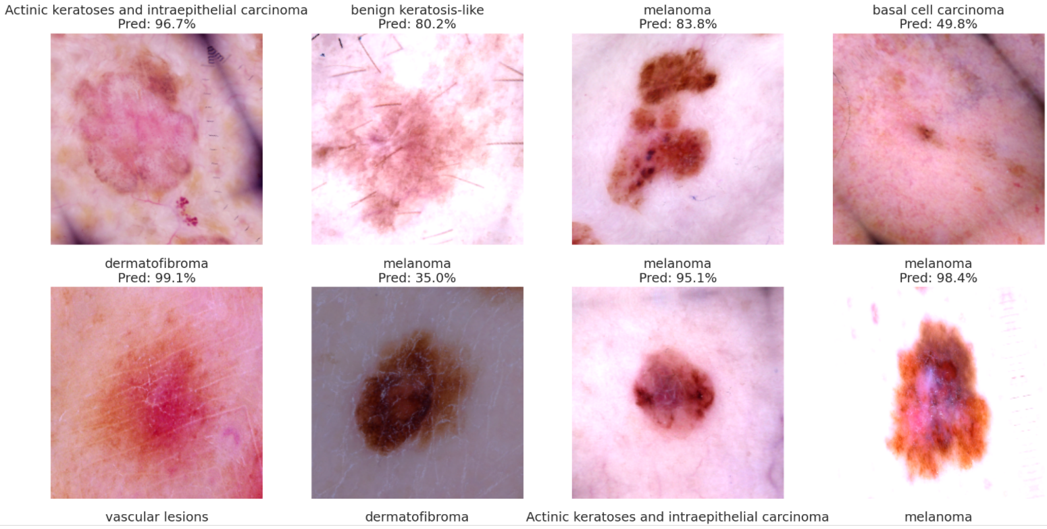

## After the second test:

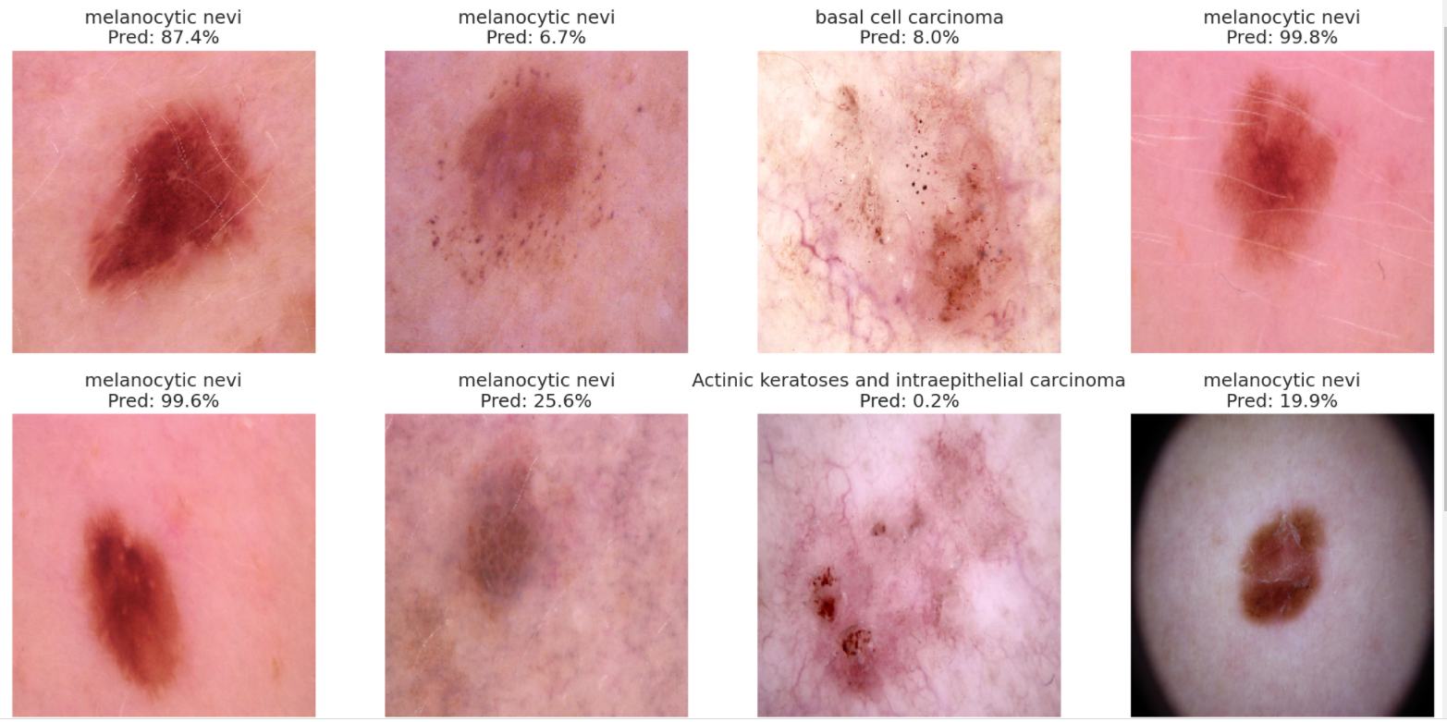

## Possible Improvements:

This model can supposedly improved with more dataset and can help doctors in the field of medical and health care. This project mainly focuses on the research of image-based data analysis and potential systems for wound assessments. We can also use different base model and try to train our model with different iteration for improved results. The project also has potential to be used for mobile image scanning and assessment the wound for a diverse classified category other than skin cancer.